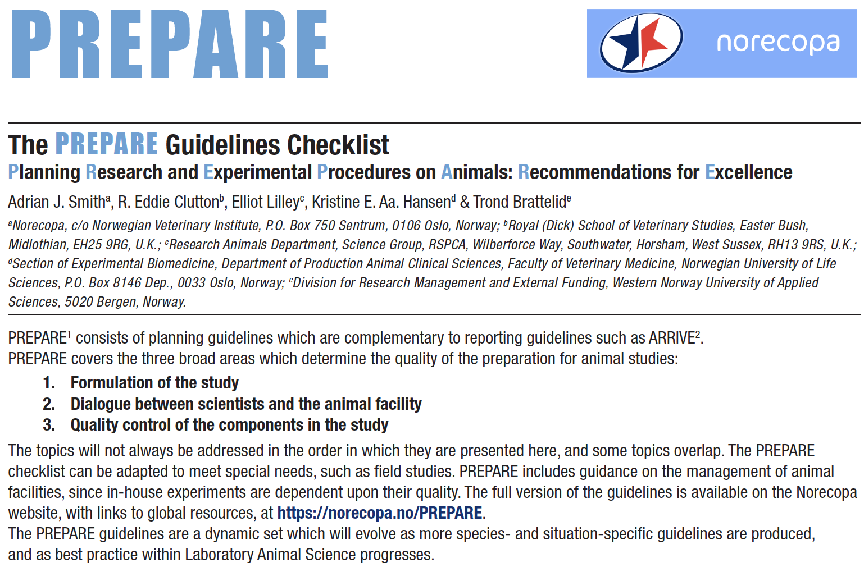

Formulation of the study

1. Literature searches
☐ Form a clear hypothesis, with primary and secondary outcomes.

☐ Consider the use of systematic reviews.

☐ Decide upon databases and information specialists to be consulted, and construct search terms.

☐ Assess the relevance of the species to be used, its biology and suitability to answer the experimental questions with the least suffering, and its welfare needs.

☐ Assess the reproducibility and translatability of the project.

2. Legal issues
☐ Consider how the research is affected by relevant legislation for animal research and other areas, e.g. animal transport, occupational health and safety.

☐ Locate relevant guidance documents (e.g. EU guidance on project evaluation).

3. Ethical issues, Harm-Benefit Assessment and humane endpoints
☐ Construct a lay summary.

☐ In dialogue with ethics committees, consider whether statements about this type of research have already been produced.

☐ Address the 3Rs (Replacement, Reduction, Refinement) and the 3Ss (Good Science, Good Sense, Good Sensibilities).

☐ Consider pre-registration and the publication of negative results.

☐ Perform a Harm-Benefit Assessment and justify any likely animal harm.

☐ Discuss the learning objectives, if the animal use is for educational or training purposes.

☐ Allocate a severity classification to the project.

☐ Define objective, easily measurable and unequivocal humane endpoints.

☐ Discuss the justification, if any, for death as an end-point.

4. Experimental design and statistical analysis
☐ Consider pilot studies, statistical power and significance levels.
☐ Define the experimental unit and decide upon animal numbers.

☐ Choose methods of randomisation, prevent observer bias, and decide upon inclusion and exclusion criteria

Dialogue between scientists and the animal facility

5. Objectives and timescale, funding and division of labour
☐ Arrange meetings with all relevant staff when early plans for the project exist.

☐ Construct an approximate timescale for the project, indicating the need for assistance with preparation, animal care, procedures and waste disposal/decontamination.

☐ Discuss and disclose all expected and potential costs.

☐ Construct a detailed plan for division of labour and expenses at all stages of the study.

6. Facility Evaluation
☐ Conduct a physical inspection of the facilities, to evaluate building and equipment standards and needs.
☐ Discuss staffing levels at times of extra risk.

7. Education and training
☐ Assess the current competence of staff members and the need for further education or training prior to the study.

8. Health risks, waste disposal and decontamination
☐ Perform a risk assessment, in collaboration with the animal facility, for all persons and animals affected directly or indirectly by the study.

☐ Assess, and if necessary produce, specific guidance for all stages of the project.

☐ Discuss means for containment, decontamination, and disposal of all items in the study.

Quality control of the components in the study

9. Test substances and procedures
☐ Provide as much information as possible about test substances.

☐ Consider the feasibility and validity of test procedures and the skills needed to perform them.

10. Experimental animals
☐ Decide upon the characteristics of the animals that are essential for the study and for reporting.

☐ Avoid generation of surplus animals.

11. Quarantine and health monitoring
☐ Discuss the animals’ likely health status, any needs for transport, quarantine and isolation, health monitoring and consequences for the personnel.

12. Housing and husbandry
☐ Attend to the animals’ specific instincts and needs, in collaboration with expert staff.
Discuss acclimation, optimal housing conditions and procedures, environmental factors and any
experimental limitations on these (e.g. food deprivation, solitary housing).

13. Experimental procedures
☐ Develop refined procedures for capture, immobilisation, marking, and release or re-homing.
☐ Develop refined procedures for substance administration, sampling, sedation and anaesthesia, surgery and other techniques.

14. Humane killing, release, re-use or re-homing
☐ Consult relevant legislation and guidelines well in advance of the study.

☐ Define primary and emergency methods for humane killing.

☐ Assess the competence of those who may have to perform these tasks.

15. Necropsy
☐ Construct a systematic plan for all stages of necropsy, including location, and identification of all animals and samples.

Other comments

